Using Read and Write for Google Chrome in a PDF

1. Add the PDF to your Google Drive
2. Locate the file in your drive

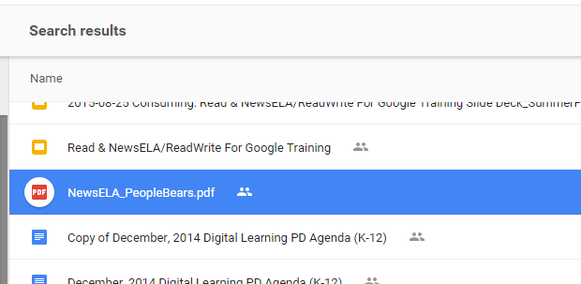

1. Right click on the file and select “Open With” -> “Read & Write for Google”

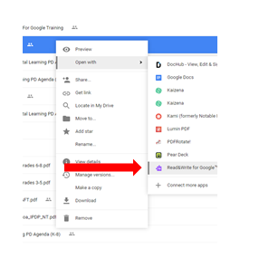

1. Once you have the document open you will see a toolbar at the top of the page.



1. Read and Write for PDF has modified tools. Note that you can type directly onto the PDF or make annotations.